**********************************************************************************

**Agile Methodology all in one**

**********************************************************************************

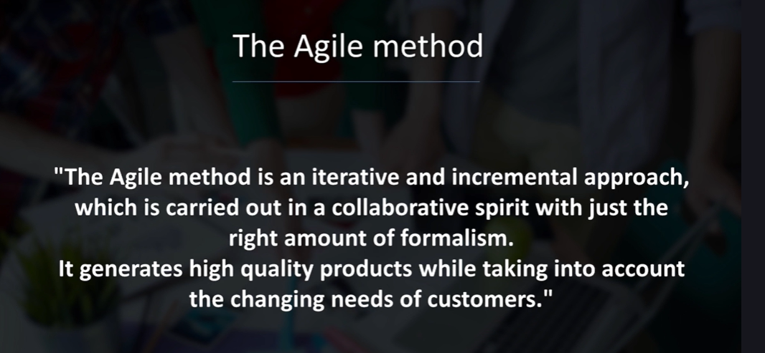

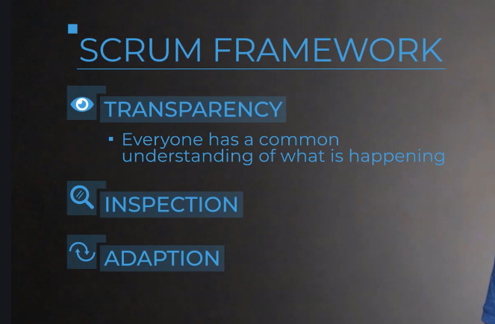

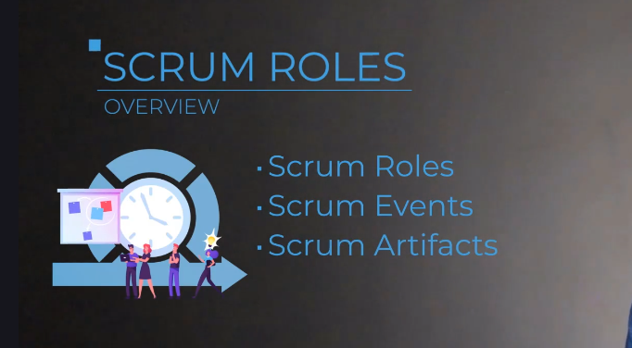

**Updates to Scrum Standards**

Scrum is the most popular Agile framework used within organizations today. In 2020, Scrum.org - the creator of Scrum standards - published an updated standards guide. While the changes to the guide are mostly verbiage (wording), it is important to understand them.

In this lecture, I am going to provide you with a quick breakdown of those changes.

**OVERVIEW:**

* The guide has been simplified tofocus more on the ***Why and What?***versusthe ***How?***
* **Reduced usage of IT and software-specific language** to increase accessibility by other teams

**SUMMARY OF CHANGES:**

* ***Development Team*** is now***Developers***to make the Scrum Team feel more inclusive, rather than two different "teams".
* ***Roles*** are now referred to as***Accountabilities*** so as to not prescribe titles roles, but rather tasks and accountabilities to enable the end result.
* Scrum Masters are no longer ***Servant leaders***but are ***True leaders***. This emphasizes now that the Scrum Master can lead from within to enable forward progress.
* Scrum Teams are now ***Self-managing***rather than ***Self-organizing***. Same concept here, just rewording to more clearly state how it is decided "who, how, and what to work on".
* Scrum Team now focuses on and iterates each Sprint toward the ***Product Goal***, which provides the desired future state of the product.

In the end, Scrum is still Scrum. It is still a lightweight framework to solve complex problems and deliver value. But this updated guide helps to simplify the language used to enable accessibility and applicability to a larger audience.

I hope this breakdown helps and I wish you nothing but success!

Happy learning,  
Jeremy, The BA Guide



